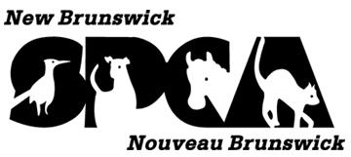  PO Box 1412 Stn A, Fredericton, NB E3B 5E3 * www.spca-nb.ca * spca@nbnet.nb.ca * 506-458-8208 |  |  |  | Winter 2008  Newsletter
 |  |  |  | 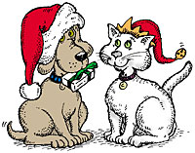
~ ~ Happy Holidays from your animal welfare partners. ~ ~

Vets to stop cosmetic pet surgery  By the summer of 2009, New Brunswick’s vets will no longer be performing ear cropping, tail docking and other cosmetic procedures on the province’s animals.  A new bylaw enacted by the New Brunswick Veterinary Medical Association in October is meant to stop the practice of performing surgeries that offer no medical or health benefit to the animal.  Declawing cats will continue, due to some owners choosing to euthanize their pet if they cannot have the procedure done.  New Brunswick is the latest region to make these changes. Breed standards have been changing as more people call for animals to be left in their natural state. Some European dog shows don’t allow cropped ears. | First NB pet food bank opens
 | 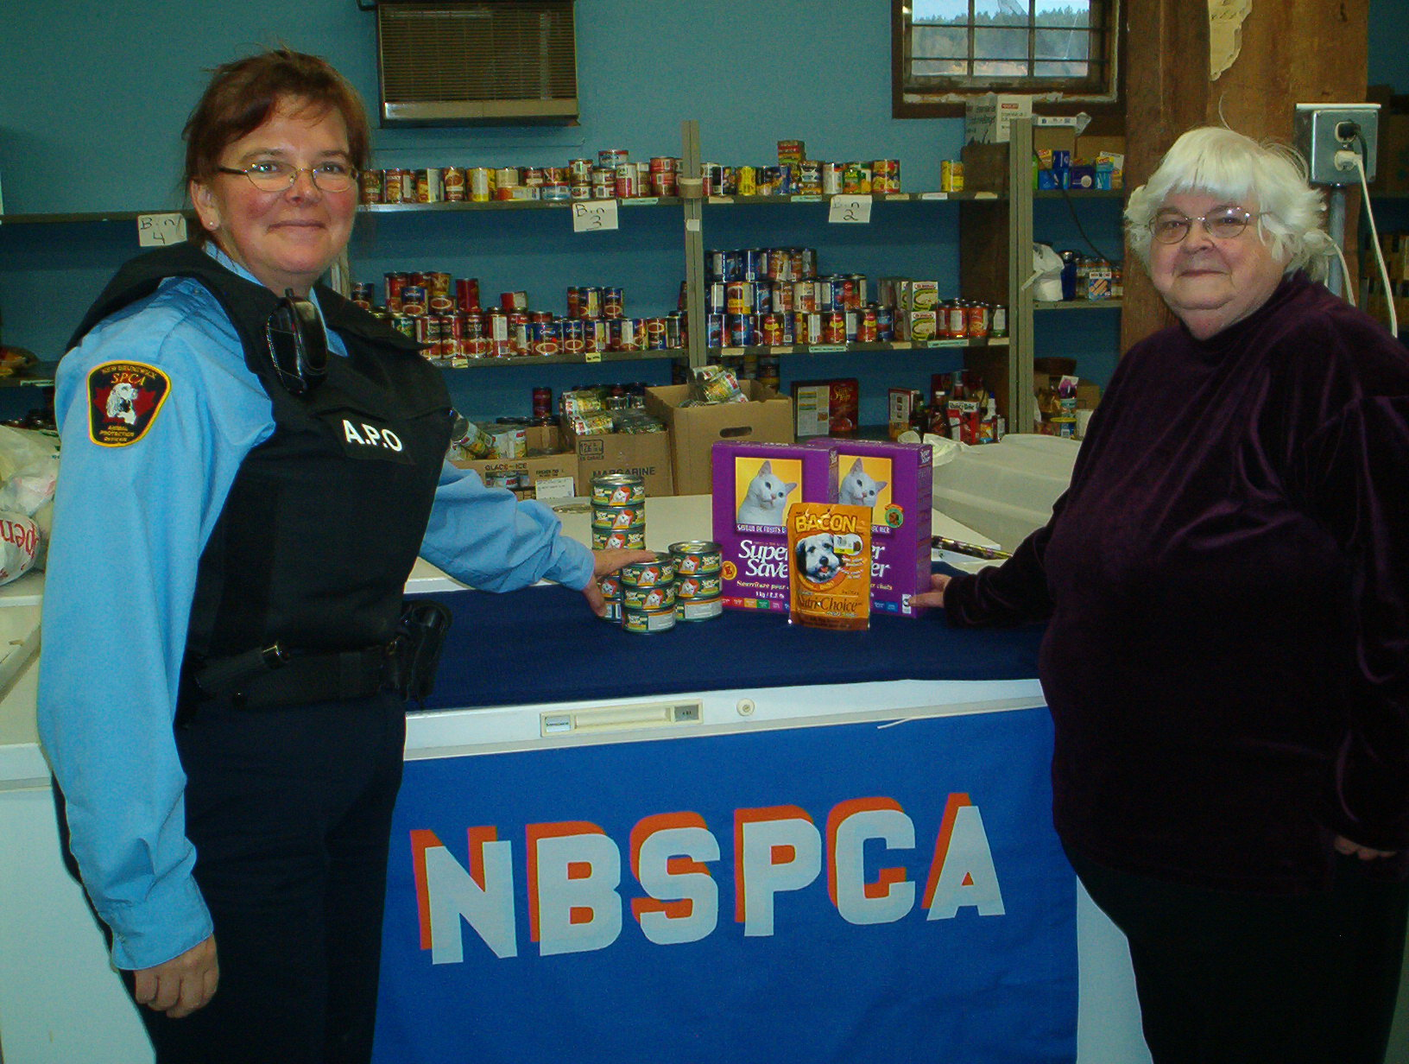  Animal protection officer Rebecca Lewis-Marshall, left, and Sussex Sharing Club administrator Maureen Sewell at the Oct. 4 launch of the Kibble Pet Food Bank, in Sussex. |  |  |  |  |  | The NBSPCA and the Sussex Sharing Club are proud to launch the first pet food bank in New Brunswick.  The two organizations are offering pet food as part of a network of these facilities the NBSPCA is working to launch around the province.  Providing cat and dog food to those in need is intended to allow existing pet parents to care for their animals. Providing help early is intended to decrease the number of abandoned and
surrendered pets, said NBSPCA executive director Glen McGuire.
This is intended to help relieve some of the pressure on area animal shelters. "We believe providing the right help at the right time is one of the most effective ways to keep pets in their homes and the cost of protecting New Brunswick’s animals down," he said. "It also means less disruption for all involved."
“We believe that companion animals are an integral part of many families and as such, add to the quality of life within the family unit. Animals provide comfort, teach compassion and actually contribute to the health and well being of people.”
Pet owners within the Sussex Sharing Club service area of Petitcodiac to Hampton to St. Martins may receive pet food once a month. Ten requests for assistance have been filled in the first month the service has been offered.
The Kibble pet food bank will provide up to one week’s worth of food per household per visit as supplies allow.
Pet food donations are accepted at the Sussex Sharing Club at 8 Court St, between 10am and 2:30pm on Tuesdays. Food may be picked up at the same venue on the second, third and fourth Thursdays, from 10 am to noon.
Call the Sussex Sharing Club at 433-6047 or the NBSPCA at 458-8208 for details on how you can help.
President’s Message  By Joy Bacon  As the year 2008 draws to a close, it is always a good time to do a bit of reflection. 2008 was a busy year around the province for both the NBSPCA and the SPCA shelters in all areas with which the provincial organization has such a great partnership.  The NBSPCA board, with representation from all areas, has met regularly and conducted the affairs of the organization. Thank you to all the board members who attend the meetings and provide such valuable direction. The inspection staff has continued to do its exceptional work responding to complaints, working to educate owners and the public and, as a last resort, removing animals to safety where there were no other options. Thanks to our hard working inspection staff for a job well done in 2008! There is no doubt the public has become more aware and more likely to report when there are situations of concern. That is a very good thing!  Shelters and local branches, with whom we have such a strong partnership, have continued to do great work in meeting their mandate of sheltering animals, finding good homes for the animals as well as educating people about the need. The first week of November was Shelter Appreciation Week and I trust that many of you were able to take advantage of open houses and learn more about the work being done.  The protection of animals is still necessary in this province as well as across the country. While we could all wish that this mandate was outdated, and no longer required, that has not been the reality for 2008 nor is it likely to be our reality for 2009. With this in mind I am hopeful that those who have been so generous in supporting our work in the past will be able to continue to do so. I am equally hopeful those who have not been able to support in someway in the past may find it possible to do so either as part of your Christmas giving or in the New Year. With tougher economic realities there is always the fear that those vulnerable are somehow left behind. We do not want this to happen in New Brunswick.  I am hopeful and looking to the future as we work together to make the need for animal protection a thing of the past.  I would wish all of our friends greetings of the season and best wishes for a prosperous and happy new year …..See you in 2009!  * * * * *  Helping animals and helping families  Animal abuse has often been a frequent sign of a larger problem of abuse in a family. By helping protect animals, you are often helping people.  A 2007 study of abused New Brunswick and PEI women found “45% of abused women surveyed said their partner deliberately threatened to harm their pets or farm animal, and, of those, 41% said their partner deliberately harmed or killed the pet.”  Katie Young of the University of New Brunswick is examining the long-term impact of these violent acts. Mothers who cared for an infant while in a violent relationship, are no longer in a violent relationship, and whose child is still under the age of three are invited to take part.  Contact her at 1-888-639-1555 or kyoung@unb.ca to learn more. |  |  |  |  |  | Join the SPCA team!

You can be part of the dedicated team of NBSPCA staff and volunteers who serve and protect New Brunswick animals.
By becoming part of the caring community who makes animal welfare an important part of their lives. Tell your friends about us and, better still, tell us about them!
Let us know who else would appreciate receiving an NBSPCA newsletter as we work together to keep New Brunswick animals healthy and safe. Happy Holidays!

--Glen McGuire, executive director

Winter 2008 edition

The NB Society for Prevention of Cruelty to Animals (NBSPCA) is a provincial organization whose mission is to promote responsible, caring and compassionate attitudes toward animals. Our primary objective is the prevention of cruelty, neglect, and abandonment of animals in our province.
President: Joy Bacon
Executive Director: Glen McGuire
Editor: Vanessa Packman
Contributors: Steve Turner, Katie Young, Judy Cole
Portions of this newsletter may be reproduced or quoted with appropriate credit. The views expressed in this newsletter are not necessarily those of the NB SPCA.

Please share this newsletter with another animal lover!
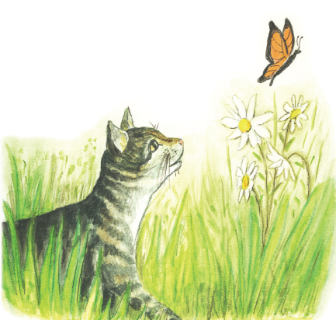  Rapport de la Presidente  Par Joy Bacon  _____________________________________________  Alors que 2008 tire à sa fin, je réfléchis sur l’année qui vient de s’écouler. L’année 2008 a été très occupée partout dans la province, tant pour la SPCANB que pour les abris locaux de la SPCA dans la province, avec lesquels l’organisme provincial entretient un excellent partenariat.  Le conseil d’administration, qui est composé de représentants de toutes les régions, s’est réuni régulièrement pour diriger les affaires de l’organisme. Je tiens à remercier tous les membres du conseil qui assistent à ces réunions et qui fournissent des conseils très valables. Les agents de protection des animaux ont continué à faire un excellent travail en répondant aux plaintes, en sensibilisant les propriétaires d’animaux et le public et en enlevant des animaux à leur propriétaire pour les placer dans un lieu sécuritaire quand il n’y avait aucune autre option. Merci à tous les agents pour leurs efforts extraordinaires en 2008. Il n’y a aucun doute que le public est plus sensibilisé et plus porté à signaler les situations inquiétantes. Cela est une très bonne chose!  Les abris et les SPCA locales ont continué à remplir leur mandat de façon exceptionnelle, en offrant refuge aux animaux, en leur trouvant de nouveaux foyers et en sensibilisant la population au problème de la surpopulation des animaux domestiques. La première semaine de novembre était la Semaine de reconnaissance des abris d’animaux et j’espère qu’un grand nombre d’entre vous ont pu en profiter pour vous rendre aux journées portes ouverts et apprendre davantage sur le travail effectué à ces endroits.  La protection des animaux est encore essentielle dans notre province et ailleurs au pays. Nous pouvons tous souhaiter que ce travail devienne redondant et ne soit plus nécessaire, mais cela n’a pas été le cas en 2008 et ce ne sera probablement pas le cas en 2009. C’est pourquoi j’espère que ceux et celles qui ont appuyé si généreusement notre travail dans le passé continueront de le faire à l’avenir. J’espère également que ceux et celles qui n’ont pas été en mesure de nous appuyer dans le passé pourront faire un don pendant la période des fêtes ou dans la nouvelle année. Compte tenu de la conjoncture économique, on craint toujours que les plus vulnérables soient oubliés. Nous ne voulons pas que cela arrive ici au Nouveau-Brunswick.  Je suis optimiste et je me réjouis à la perspective de travailler ensemble pour qu’un jour on n’ait plus besoin de services de protection des animaux.  Je souhaite à tous nos amis de joyeuses fêtes et une nouvelle année remplie de bonheur et de prospérité. Au plaisir de vous reparler en 2009! |  |  |  |  | Tiggy Tiger books help NBSPCA  A new three-book series on the adventures of Tiggy Tiger is benefiting the NBSPCA.  Children can enjoy cheering on the three-legged hero tabby through his exploits: The Adventures of Tiggy Tiger, the Three-Legged Tomcat; Tiggy Tiger and the Great Escape; and Tiggy Tiger Lost on the Best Vacation Ever.  Author Judy Cole and illustrator Linda McCarthy teamed up to capture what started as bedtime stories for Cole’s grandson into books many Maritime children could relish.  The Woodstock area sisters enjoyed sharing the unbeatable spirit of the plucky tomcat who inspired those who knew him for more than 17 years.  The books were launched in October and are available for in time to go under the Christmas tree. One dollar from each book sold will go to the NBSPCA.  You will find them on sale at Westminster Books in Fredericton, Owl’s Nest in Woodstock or through the NBSPCA office. Learn more about the unstoppable cat at  www.tiggybooks.ca
 |  | Rick Kelly brings dedication & humour to animal protection
A retired Canadian soldier who proudly protected his country is now protecting New Brunswick animals.
Rick Kelly and NBSPCA chief inspector Paul Melanson met while serving in the Canadian Forces, where he was a military police investigator and Paul a dog-handler. Rick is a native of Fredericton, and both he and Paul made Fredericton their home after completing their military careers. When Paul become Chief Inspector of the NBSPCA in 2001, he thought of Rick’s life-time love of animals and his skills. Soon Rick became part of the new group of Inspectors formed as part of the NBSPCA’s re-organization.
Today Rick describes himself as a “long-timer,” and holds the position of Sergeant in charge of assisting and supervising six other Inspectors in the southern part of the province. He’s bluff and funny about his work as an Inspector. “I’ve worn out 17 pairs of boots and two trucks for the SPCA,” he jokes, and “I’ve been chased, and bitten 50 times!” He’s also been on the front line of some of the society’s most challenging and disturbing cases as a result of his supervisory role. “Puppy mills are my forte,” he says, and he recalls being in on at least 12 operations against puppy mills, the number of animals needing rescue ranging from 12 up to 300.
He gets visibly angry thinking about some of those cases. “We see horrible conditions,” he says, with dogs intended to be sold for $600 each living in their own filth in wire cages two feet by three feet in unheated sheds and windowless trailers. “And the number of large animals we are dealing with is growing, too,” he observes. |  |  | “I’ve worn out 17 pairs of boots and two trucks for the SPCA,”  he jokes, and “I’ve been chased, and bitten 50 times!”
Asked to name the case that stands out in his memory, he recalls finding two starving horses confined in total darkness in a garage, the manure so deep that in standing on it the horses were unable to raise their heads. The horses were seized, and despite predictions by veterinarians they would never live, they were turned over to a horse-rescue group that nursed them back to help and found them new homes.
Rick’s irrepressible sense of humour never lets him dwell on the dark side of the work too long. He remembers a call by a desperate local landlord about a tenant who had abandoned a very large ball python in an apartment. He and Paul went to investigate, carrying a forked pole and a snake-bag. “I don’t want to lose my reputation as a responsible senior inspector,” Rick noted, “but on that day I was happy to let my chief demonstrate to me the proper technique for handling an eight-foot snake, while I looked on from a distance.”
Rick takes pride in the NBSPCA and in the corps of Inspectors he helps to supervise. “We’re making real progress,” he says. “We’ve got quality people, and they’re getting better trained and better equipped all the time.” And there’s dedication among the inspectors. “If you’re in it for the money, you’d better forget SPCA work, folks,” he says. “The normal thing is that you put in 50 hours and ask to get paid for 20.”
“We need more recognition (by the public, law enforcement agencies, and legislators),” he says of what the NBSPCA needs most today. “We’ve got to put some teeth in the SPCA Act,” he says, and stop letting those who neglect or abuse animals off with small fines that in other provinces might even bring prison sentences. “But the SPCA’s making progress,” he repeats, “and I’m glad to be part of it.”

